**Project Design Phase-II**

**Data Flow Diagram & User Stories**

|  |  |
| --- | --- |
| Date | 1 May 2023 |
| Team ID | NM2023TMID09251 |
| Project Name | Industrial Workers Health and Safety System based on Internet of Things |

**Data Flow Diagrams:**

A Data Flow Diagram (DFD) is a traditional visual representation of the information flows within a system. A neat and clear DFD can depict the right amount of the system requirement graphically. It shows how data enters and leaves the system, what changes the information, and where data is stored.

**Architecture**

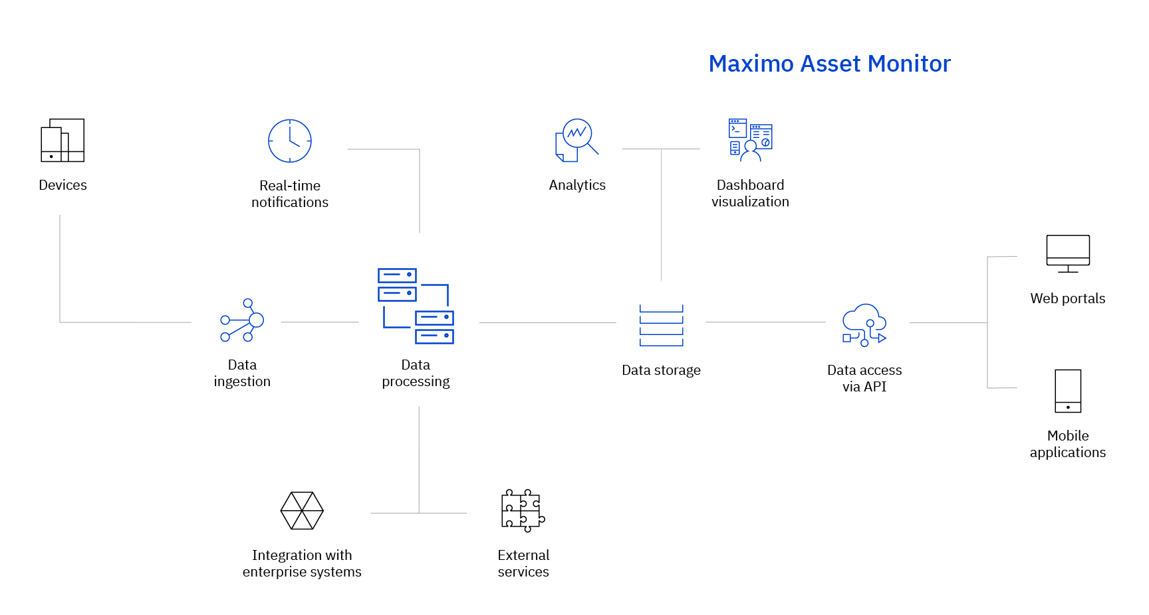

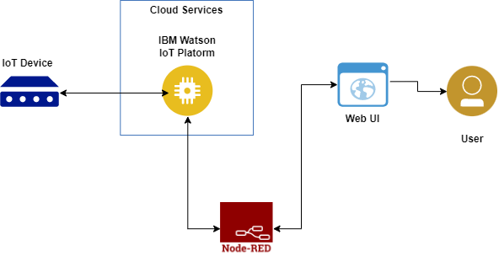

Gain knowledge of Watson IoT Platform

Explore Wokwi Platform

Explore the devices and its simulation of the wokwi platform.

Explore the libraries present in Wokwi.

Will be able to code to connect the devices across the cloud platform.

Connecting the devices on wokwi to the IoT platform device to exchange the sensor data.

Gain knowledge of creating devices and platforms using IBM Watson IoT Platform.

Gain knowledge of web application development through node-red.

Use the below template to list all the user stories for the product.

| **User Type** | **Functional Requirement (Epic)** | **User Story Number** | **User Story / Task** | **Acceptance criteria** | **Priority** | **Team Member** |
| --- | --- | --- | --- | --- | --- | --- |
| Customer | Registration | USN-1 | As a user, I can register for the application by entering my email, password, and confirming my password. | I can access my account / dashboard | High | Prakash raj |
|  |  | USN-2 | As a user, I will receive confirmation email once I have registered for the application | I can receive confirmation email & click confirm | High | Praveen kumar |
|  |  | USN-3 | As a user, I can register for the application through Gmail |  | Medium | vijayasharma |
|  | Login | USN-4 | As a user, I can log into the application by entering email & password |  | High | Vetri raja |
|  | Dashboard | USN-5 | User can the see data of the devices from cloud |  | high | Prakash raj |